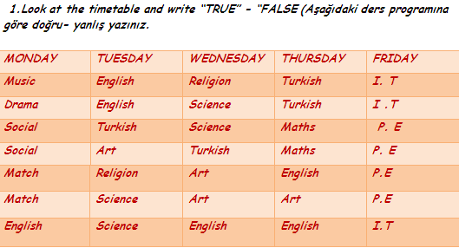
- ÜNİTE QUIZ - HELLO

a) I have got double Turkish on Thursday ............................
b) I haven’t got any Music on Monday .................................
c) I have got Maths on Tueasday .......................................
d) I haven’t got any Turkish on Friday ................................
e) My Religion lesson is on Tuesday and Wednesday ...................

2.Resim altına uygun ders isimlerini yazınız.
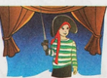

 |  | 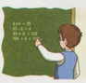
MÜZİK | 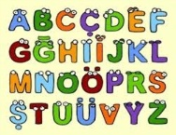 |  | 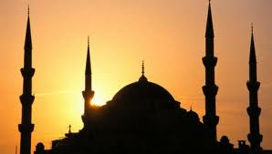
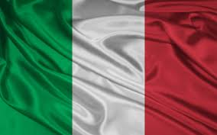
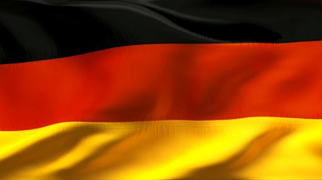
3. Match the flags of countries with their official languages.

......................... ......................... ........................

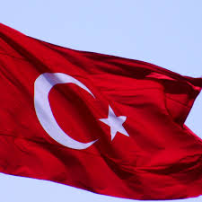
- Italian
- English
- Turkish
- Spanish
- French

.......................... ..........................

4. Fill in the information card according to a speech bubble. (Konuşma balonuna göre bilgi kartını doldurunuz.)
Hello! My name is Ceren. I’m 10 years old. I am from Turkey and I am Turkish. I speak English, Turkish and German . My favorite lessons are English and Art

